

**Volunteer working page layout and working details**

***NOTE: Details of each filed has been described below the pic***

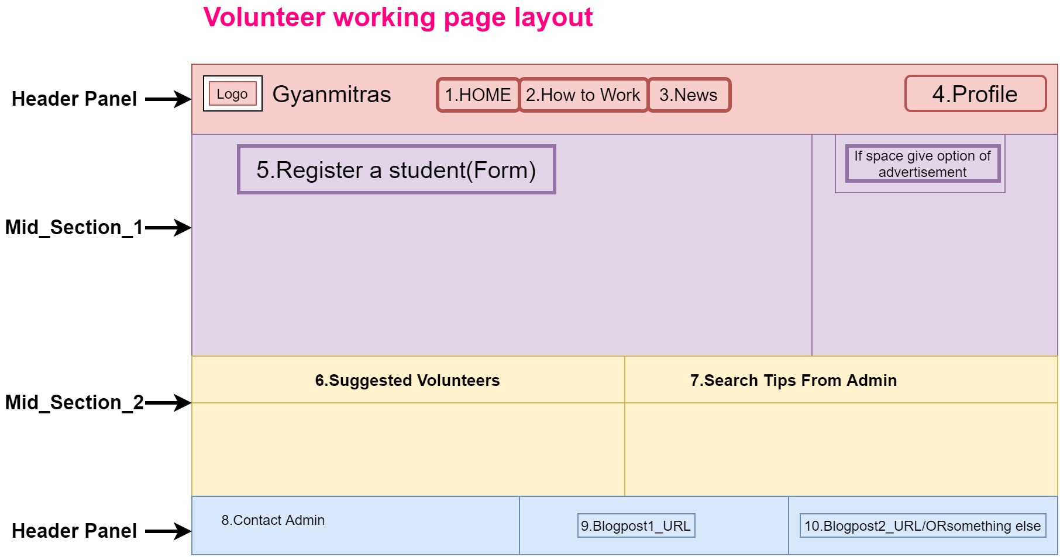

**Details of each fields (1-9)**

|  |
| --- |
| **1.Home**  **This will redirect to index page.** |
| **2.How to work**  **It will redirect to another page where videos and sliders will be shown to guide the volunteer.** |
| **3.News**  **Just a hyperlink of blog post should be provided which exact link will be updated after making an appropriate blog.** |
| **4.Profile**  **Profile should have following details and sub-details.**   |  |  | | --- | --- | | **His photo should be on top** | **Count of students enrolled by him/her should also be shown at top** | | **Name** | **Edit** | | **Permanent address** | **Edit** | | **Mail id** | **Edit & Verify** | | **Contact** | **Edit & Verify** | | **Area of search** | **Edit** | | **Logout** |  |   **5.Register a student form**  ***Form field values with description***   |  |  | | --- | --- | | **\*Name of student** |  | | **Contact of student** |  | | **\*Guardian’s Contact** |  | | **Email Id** |  | | **\*Address** | **State /Dist/ dropdown** | | **\*Do you have smartphone?** | **YES NO** | | **\*Do you have a PC?** | **YES NO** | | **\*Do you want to be adopted academically?** |  | | **\*\*Unable to continue with the form**  **Get a phone call?** | **If Yes->Enter mobile (Terminate registration)**  **->Registration should be done by telephonic contact**  **If No->Submit** | | **Provide a terms and conditions popup after which submit should be done** |  |   **6.Suggested volunteers**  **Provide a table where show at most 5 volunteers detail from matching details of this volunteer.**  **Only Name and Contact should be shared.**   |  |  | | --- | --- | | **Name** | **Contact** | | **Volunteer from same area 1** | **Contact 1** | | **Volunteer from same area 2** | **Contact 2** | | **Volunteer from same area 3** | **Contact 3** | | **Volunteer from same area 4** | **Contact 4** | | **Volunteer from same area 5** | **Contact 5** |   **7.Search tips from admins**  **Provide such UI where area based search tips can be shown which will be uploaded by admin on the behalf of area of search of that particular volunteer.**  **8.Contact admin**  **A form should be provided to the volunteer to contact admin**   |  |  | | --- | --- | | **Form _Fields** | **Description** | | **Query on mail** | **Mail id of admin should be provided** | | **Get call** | **A call request to the admin should be generated** |   **9.Blogpost1_Url**  **Some URLs of some blog posts should be provided**  **10.Blogpost2_Url**  **Some URLs of some blog posts should be provided** |